From Java code to Java heap

Understanding and optimizing your application's memory usage

Although the subject of optimizing your application code's memory usage isn't new, it's not one that is generally well understood. This article briefly covers the memory usage of a Java process, then digs in depth into the memory usage of the Java code that you write. Finally, it shows ways to make your application code more memory-efficient, particularly in the area of using Java collections such as HashMaps and ArrayLists.

## **Background: Memory usage of a Java process**

When you run a Java application by executingjava on the command line or by starting some Java-based middleware, the Java runtime creates an operating-system process — just as if you were running a C-based program. In fact, most JVMs are written largely in C or C++. As an operating-system process, the Java runtime faces the same restrictions on memory as any other process: the addressability provided by the architecture, and the user space provided by the operating system.

The memory addressability provided by the architecture depends on the bit size of the processor — for example, 32 or 64 bits, or 31 bits in the case of the mainframe. The number of bits the process can handle determines the range of memory that the processor is capable of addressing: 32 bits provides an addressable range of 2^32, which is 4,294,967,296 bits, or 4GB. The addressable range for a 64-bit processor is significantly larger: 2^64 is 18,446,744,073,709,551,616, or 16 exabytes.

Some of the addressable range provided by the processor architecture is used by the OS itself for its kernel and (for JVMs written in C or C++) for the C runtime. The amount of memory used by the OS and C runtime depends on the OS being used, but it is usually significant: the default usage by Windows is 2GB. The remaining addressable space — termed the user space — is the memory available to the actual process that's running.

For Java applications, then, the user space is the memory used by the Java process, effectively consisting of two pools: the Java heap(s) and the native (non-Java) heap. The size of the Java heap is controlled by the JVM's Java heap settings: -Xms and -Xmx set the minimum and maximum Java heap, respectively. The native heap is the user space left over after the Java heap has been allocated at the maximum size setting. Figure 1 shows an example of what this might look like for a 32-bit Java process:

##### **Figure 1. Example memory layout for a 32-bit Java process**

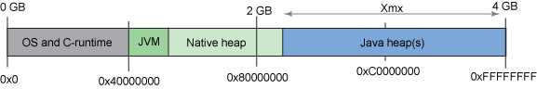

In [Figure 1](https://www.ibm.com/developerworks/library/j-codetoheap/#fig1), the OS and C runtime use about 1GB of the 4GB of addressable range, the Java heap uses almost 2GB, and the native heap uses the rest. Note that the JVM itself uses memory — the same way the OS kernel and C runtime do — and that the memory the JVM uses is a subset of the native heap.

## **Anatomy of a Java object**

When your Java code uses the new operator to create an instance of a Java object, much more data is allocated than you might expect. For example, it might surprise you to know that the size ratio of an int value to an Integer object — the smallest object that can hold an int value — is typically 1:4. The additional overhead is metadata that the JVM uses to describe the Java object, in this case an Integer.

The amount of object metadata varies by JVM version and vendor, but it typically consists of:

* **Class**: A pointer to the class information, which describes the object type. In the case of a java.lang.Integer object, for example, this is a pointer to the java.lang.Integer class.
* **Flags**: A collection of flags that describe the state of the object, including the hash code for the object if it has one, and the shape of the object (that is, whether or not the object is an array).
* **Lock**: The synchronization information for the object — that is, whether the object is currently synchronized.

The object metadata is then followed by the object data itself, consisting of the fields stored in the object instance. In the case of a java.lang.Integer object, this is a single int.

So, when you create an instance of a java.lang.Integer object when running a 32-bit JVM, the layout of the object might look like Figure 2:

##### **Figure 2. Example layout of a java.lang.Integer object for a 32-bit Java process**

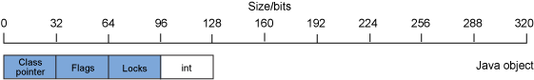

As [Figure 2](https://www.ibm.com/developerworks/library/j-codetoheap/#fig2) shows, 128 bits of data are used to store the 32 bits of data in the intvalue, because the object metadata uses the rest of those 128 bits.

## **Anatomy of a Java array object**

The shape and structure of an array object, such as an array of int values, is similar to that of a standard Java object. The primary difference is that the array object has an additional piece of metadata that denotes the array's size. An array object's metadata, then, consists of:

* **Class**: A pointer to the class information, which describes the object type. In the case of an array of int fields, this is a pointer to the int[] class.
* **Flags**: A collection of flags that describe the state of the object, including the hash code for the object if it has one, and the shape of the object (that is, whether or not the object is an array).
* **Lock**: The synchronization information for the object — that is, whether the object is currently synchronized.
* **Size**: The size of the array.

Figure 3 shows an example layout for an int array object:

##### **Figure 3. Example layout of an int array object for a 32-bit Java process**

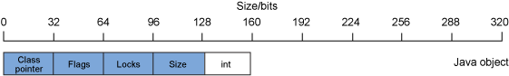

In [Figure 3](https://www.ibm.com/developerworks/library/j-codetoheap/#fig3), 160 bits of data store the 32 bits of data in the int value, because the array metadata uses the rest of those 160 bits. For primitives such as byte, int, and long, a single-entry array is more expensive in terms of memory than the corresponding wrapper object (Byte, Integer, or Long) for the single field.

## **Anatomy of more-complex data structures**

Good object-oriented design and programming encourage the use ofencapsulation (providing interface classes that control access to data) and delegation (the use of helper objects to carry out tasks). Encapsulation and delegation cause the representation of most data structures to involve multiple objects. A simple example is a java.lang.String object. The data in ajava.lang.String object is an array of characters that is encapsulated by ajava.lang.String object that manages and controls access to the character array. The layout of a java.lang.String object for a 32-bit Java process might look like Figure 4:

##### **Figure 4. Example layout of a java.lang.String object for a 32-bit Java process**

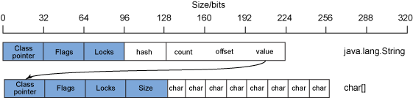

As [Figure 4](https://www.ibm.com/developerworks/library/j-codetoheap/#fig4) shows, a java.lang.String object contains — in addition to the standard object metadata — some fields to manage the string data. Typically, these fields are a hash value, a count of the size of the string, the offset into the string data, and an object reference to the character array itself.

This means that to have a string of 8 characters (128 bits of char data), 256 bits of data are for the character array and 224 bits of data are for thejava.lang.String object that manages it, making a total of 480 bits (60 bytes) to represent 128 bits (16 bytes) of data. This is an overhead ratio of 3.75:1.

In general, the more complex a data structure becomes, the greater its overhead. This is discussed in more detail in the next section.

## **32-bit and 64-bit Java objects**

The sizes and overhead for the objects in the preceding examples apply to a 32-bit Java process. As you know from the [Background: Memory usage of a Java process](https://www.ibm.com/developerworks/library/j-codetoheap/#Background) section, a 64-bit processor has a much higher level of memory addressability than a 32-bit processor. With a 64-bit process, the size of some of the data fields in the Java object — specifically, the object metadata and any field that refers to another object — also need to increase to 64 bits. The other data-field types — such as int, byte, and long — do not change in size. Figure 5 shows the layout for a 64-bit Integer object and for an int array:

##### **Figure 5. Example layout of a java.lang.Integer object and an int array for a 64-bit Java process**

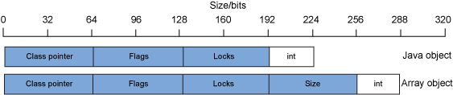

[Figure 5](https://www.ibm.com/developerworks/library/j-codetoheap/#fig5) shows that for a 64-bit Integer object, 224 bits of data are now being used to store the 32 bits used for the int field — an overhead ratio of 7:1. For a 64-bit single-element int array, 288 bits of data are used to store the 32-bit intentry — an overhead of 9:1. The effect of this on real applications is that the Java heap memory usage of an application that previously ran on a 32-bit Java runtime increases dramatically when it's moved to a 64-bit Java runtime. Typically, the increase is on the order of 70 percent of the original heap size. For example, a Java application using 1GB of Java heap with the 32-bit Java runtime will typically use 1.7GB of Java heap with the 64-bit Java runtime.

Note that this memory increase is not limited to the Java heap. The native-heap memory-area usage will also increase, sometimes by as much as 90 percent.

Table 1 shows the field sizes for objects and arrays when an application runs in 32-bit and 64-bit mode:

##### **Table 1. Field sizes in objects for 32-bit and 64-bit Java runtimes**

| **Field type** | **Field size (bits)** | | | |
| --- | --- | --- | --- | --- |
| **Object** | | **Array** | |
| **32-bit** | **64-bit** | **32-bit** | **64-bit** |
| boolean | 32 | 32 | 8 | 8 |
| byte | 32 | 32 | 8 | 8 |
| char | 32 | 32 | 16 | 16 |
| short | 32 | 32 | 16 | 16 |
| int | 32 | 32 | 32 | 32 |
| float | 32 | 32 | 32 | 32 |
| long | 64 | 64 | 64 | 64 |
| double | 64 | 64 | 64 | 64 |
| Object fields | 32 | 64 (32*) | 32 | 64 (32*) |
| Object metadata | 32 | 64 (32*) | 32 | 64 (32*) |

*The size of the object fields and of the data used for the each of the object-metadata entries can be reduced to 32 bits via the [Compressed References or Compressed OOPs](https://www.ibm.com/developerworks/library/j-codetoheap/#CompressedRefs) technologies.

### **Compressed References and Compressed Ordinary Object Pointers (OOPs)**

IBM and Oracle JVMs both provide object-reference compression capabilities via the Compressed References (-Xcompressedrefs) and Compressed OOPs (-XX:+UseCompressedOops) options, respectively. Use of these options enables the object fields and the object metadata values to be stored in 32 bits rather than 64 bits. This has the effect of negating the 70 percent Java-heap memory increase when an application is moved from a 32-bit Java runtime to a 64-bit Java runtime. Note that the options have no effect on the memory usage of the native heap; it is still higher with the 64-bit Java runtime than with the 32-bit Java runtime.

## **Memory usage of Java collections**

In most applications, a large amount of data is stored and managed using the standard Java Collections classes provided as part of the core Java API. If memory-footprint optimization is important for your application, it's especially useful to understand the function each collection provides and the associated memory overhead. In general, the higher the level of a collection's functional capabilities, the higher its memory overhead — so using collection types that provide more function than you require will incur unnecessary additional memory overhead.

Some of the commonly used collections are:

* [HashSet](https://www.ibm.com/developerworks/library/j-codetoheap/#HashSet)
* [HashMap](https://www.ibm.com/developerworks/library/j-codetoheap/#HashMap)
* [Hashtable](https://www.ibm.com/developerworks/library/j-codetoheap/#Hashtable)
* [LinkedList](https://www.ibm.com/developerworks/library/j-codetoheap/#LinkedList)
* [ArrayList](https://www.ibm.com/developerworks/library/j-codetoheap/#ArrayList)

With the exception of HashSet, this list is in decreasing order of both function and memory overhead. (A HashSet, being a wrapper around a HashMap object, effectively provides less function than HashMap whilst being slightly larger.)

### **Java Collections: HashSet**

A HashSet is an implementation of the Set interface. The Java Platform SE 6 API documentation describes HashSet as:

A collection that contains no duplicate elements. More formally, sets contain no pair of elements e1 and e2 such that e1.equals(e2), and at most one null element. As implied by its name, this interface models the mathematical set abstraction.

A HashSet has fewer capabilities than a HashMap in that it cannot contain more than one null entry and cannot have duplicate entries. The implementation is a wrapper around a HashMap, with the HashSet object managing what is allowed to be put into the HashMap object. The additional function of restricting the capabilities of a HashMap means that HashSets have a slightly higher memory overhead.

Figure 6 shows the layout and memory usage of a HashSet on a 32-bit Java runtime:

##### **Figure 6. Memory usage and layout of a HashSet on a 32-bit Java runtime**

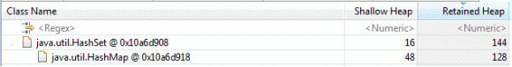

[Figure 6](https://www.ibm.com/developerworks/library/j-codetoheap/#fig6) shows the shallow heap (memory usage of the individual object) in bytes, along with the retained heap (memory usage of the individual object and its child objects) in bytes for a java.util.HashSet object. The shallow heap size is 16 bytes, and the retained heap size is 144 bytes. When a HashSet is created, its default capacity — the number of entries that can be put into the set — is 16 entries. When a HashSet is created at the default capacity and no entries are put into the set, it occupies 144 bytes. This is an extra 16 bytes over the memory usage of a HashMap. Table 2 shows the attributes of a HashSet:

##### **Table 2. Attributes of a HashSet**

| **Attribute** | **Description** |
| --- | --- |
| **Default capacity** | 16 entries |
| **Empty size** | 144 bytes |
| **Overhead** | 16 bytes plus HashMap overhead |
| **Overhead for a 10K collection** | 16 bytes plus HashMap overhead |
| **Search/insert/delete performance** | O(1) — Time taken is constant time, regardless of the number of elements (assuming no hash collisions) |

### **Java Collections: HashMap**

A HashMap is an implementation of the Map interface. The Java Platform SE 6 API documentation describes HashMap as:

An object that maps keys to values. A map cannot contain duplicate keys; each key can map to at most one value.

HashMap provides a way of storing key/value pairs, using a hashing function to transform the key into an index into the collection where the key/value pair is stored. This allows for fast access to the data location. Null entries and duplicate entries are allowed; as such, a HashMap is a simplification of a HashSet.

The implementation of a HashMap is as an array of HashMap$Entry objects. Figure 7 shows the memory usage and layout of a HashMap on a 32-bit Java runtime:

##### **Figure 7. Memory usage and layout of a HashMap on a 32-bit Java runtime**

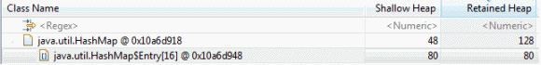

As [Figure 7](https://www.ibm.com/developerworks/library/j-codetoheap/#fig7) shows, when a HashMap is created, the result is a HashMap object and an array of HashMap$Entry objects at its default capacity of 16 entries. This gives a HashMap a size of 128 bytes when it is completely empty. Any key/value pairs inserted into the HashMap are wrapped by a HashMap$Entry object, which itself has some overhead.

Most implementations of HashMap$Entry objects contain the following fields:

* int KeyHash
* Object next
* Object key
* Object value

A 32-byte HashMap$Entry object manages the key/value pairs of data that are put into the collection. This means that the total overhead of a HashMap consists of the HashMap object, a HashMap$Entry array entry, and a HashMap$Entry object for each entry. This can be expressed by the formula:

HashMap object + Array object overhead + (number of entries * (HashMap$Entry array entry + HashMap$Entry object))

For a 10,000-entry HashMap, the overhead of just the HashMap, HashMap$Entryarray, and HashMap$Entry objects is approximately 360K. This is before the size of the keys and values being stored is taken into account.

Table 3 shows HashMap's attributes:

##### **Table 3. Attributes of a HashMap**

| **Attribute** | **Description** |
| --- | --- |
| **Default capacity** | 16 entries |
| **Empty size** | 128 bytes |
| **Overhead** | 64 bytes plus 36 bytes per entry |
| **Overhead for a 10K collection** | ~360K |
| **Search/insert/delete performance** | O(1) — Time taken is constant time, regardless of the number of elements (assuming no hash collisions) |

### **Java Collections: Hashtable**

Hashtable, like HashMap, is an implementation of the Map interface. The Java Platform SE 6 API documentation's description of Hashtable is:

This class implements a hashtable, which maps keys to values. Any non-null object can be used as a key or as a value.

Hashtable is very similar to HashMap, but it has two limitations. It cannot accept null values for either the key or the value entries, and it is a synchronized collection. In contrast, HashMap can accept null values and is not synchronized but can be made synchronized using the Collections.synchronizedMap()method.

The implementation of Hashtable — also similar to HashMap's — is as an array of entry objects, in this case Hashtable$Entry objects. Figure 8 shows the memory usage and layout of a Hashtable on a 32-bit Java runtime:

##### **Figure 8. Memory usage and layout of a Hashtable on a 32-bit Java runtime**

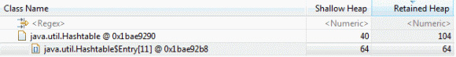

[Figure 8](https://www.ibm.com/developerworks/library/j-codetoheap/#fig8) shows that when a Hashtable is created, the result is a Hashtable object using 40 bytes of memory along with an array of Hashtable$entrys with a default capacity of 11 entries, totaling a size of 104 bytes for an emptyHashtable.

Hashtable$Entry stores effectively the same data as HashMap:

* int KeyHash
* Object next
* Object key
* Object value

This means that the Hashtable$Entry object is also 32 bytes for key/value entry in the Hashtable, and the calculation for Hashtable overhead and size of a 10K entry collection (approximately 360K) is similar to HashMap's.

Table 4 shows the attributes of a Hashtable:

##### **Table 4. Attributes of a Hashtable**

| **Attribute** | **Description** |
| --- | --- |
| **Default capacity** | 11 entries |
| **Empty size** | 104 bytes |
| **Overhead** | 56 bytes plus 36 bytes per entry |
| **Overhead for a 10K collection** | ~360K |
| **Search/insert/delete performance** | O(1) — Time taken is constant time, regardless of the number of elements (assuming no hash collisions) |

As you can see, Hashtable has a slightly smaller default capacity than HashMap(11 vs. 16). Otherwise, the main differences are Hashtable's inability to accept null keys and values, and its default synchronisation, which may not be needed and reduces the collection's performance.

### **Java Collections: LinkedList**

A LinkedList is a linked-list implementation of the List interface. The Java Platform SE 6 API documentation describes LinkedList as:

An ordered collection (also known as a sequence). The user of this interface has precise control over where in the list each element is inserted. The user can access elements by their integer index (position in the list), and search for elements in the list. Unlike sets, lists typically allow duplicate elements.

The implementation is a linked list of LinkedList$Entry objects. Figure 9 shows the memory usage and layout of LinkedList on a 32-bit Java runtime:

##### **Figure 9. Memory usage and layout of a LinkedList on a 32-bit Java runtime**

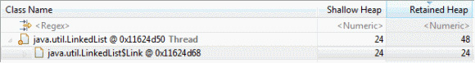

[Figure 9](https://www.ibm.com/developerworks/library/j-codetoheap/#fig9) shows that when a LinkedList is created, the result is a LinkedListobject using 24 bytes of memory along with a single LinkedList$Entry object, totaling 48 bytes of memory for an empty LinkedList.

One of the advantages of linked lists is that they are accurately sized and do not need to be resized. The default capacity is effectively one entry, and this grows and shrinks dynamically as more entries are added or removed. There is still an overhead for each LinkedList$Entry object, whose data fields are:

* Object previous
* Object next
* Object value

But this is smaller than the overhead of HashMaps and Hashtables, because linked lists store only a single entry rather than a key/value pair, and there's no need to store a hash value because array-based lookups are not used. On the negative side, lookups into a linked list can be much slower, because the linked list must be traversed in order for the correct entry to be found. For large linked lists, that can result in long lookup times.

Table 5 shows the attributes of a LinkedList:

##### **Table 5. Attributes of a LinkedList**

| **Attribute** | **Description** |
| --- | --- |
| **Default capacity** | 1 entry |
| **Empty size** | 48 bytes |
| **Overhead** | 24 bytes, plus 24 bytes per entry |
| **Overhead for a 10K collection** | ~240K |
| **Search/insert/delete performance** | O(n) — Time taken is linearly dependent on the number of elements |

### **Java Collections: ArrayList**

An ArrayList is a resizeable array implementation of the List interface. The Java Platform SE 6 API documentation describes ArrayList as:

An ordered collection (also known as a sequence). The user of this interface has precise control over where in the list each element is inserted. The user can access elements by their integer index (position in the list), and search for elements in the list. Unlike sets, lists typically allow duplicate elements.

Unlike LinkedList, ArrayList is implemented using an array of Objects. Figure 10 shows the memory usage and layout of an ArrayList on a 32-bit Java runtime:

##### **Figure 10. Memory usage and layout of an ArrayList on a 32-bit Java runtime**

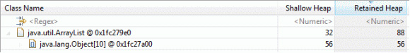

[Figure 10](https://www.ibm.com/developerworks/library/j-codetoheap/#fig10) shows that when an ArrayList is created, the result is an ArrayListobject using 32 bytes of memory, along with an Object array at a default size of 10, totaling 88 bytes of memory for an empty ArrayList This means that theArrayList is not accurately sized and therefore has a default capacity, which happens to be 10 entries.

Table 6 shows attributes of an ArrayList:

##### **Table 6. Attributes of an ArrayList**

| **Attribute** | **Description** |
| --- | --- |
| **Default capacity** | 10 |
| **Empty size** | 88 bytes |
| **Overhead** | 48 bytes plus 4 bytes per entry |
| **Overhead for 10K collection** | ~40K |
| **Search/insert/delete performance** | O(n) — Time taken is linearly dependent to the number of elements |

### **Other types of "collections"**

In addition to the standard collections, StringBuffer can also be considered a collection in that it manages character data and is similar in structure and capabilities to the other collections. The Java Platform SE 6 API documentation describes StringBuffer as:

A thread-safe, mutable sequence of characters.... Every string buffer has a capacity. As long as the length of the character sequence contained in the string buffer does not exceed the capacity, it is not necessary to allocate a new internal buffer array. If the internal buffer overflows, it is automatically made larger.

The implementation of a StringBuffer is as an array of chars. Figure 11 shows the memory usage and layout of a StringBuffer on a 32-bit Java runtime:

##### **Figure 11. Memory usage and layout of a StringBuffer on a 32-bit Java runtime**

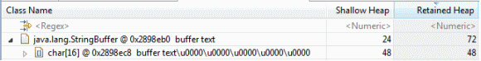

[Figure 11](https://www.ibm.com/developerworks/library/j-codetoheap/#fig11) shows that when a StringBuffer is created, the result is aStringBuffer object using 24 bytes of memory, along with a character array with a default size of 16, totaling 72 bytes of data for an empty StringBuffer.

Like the collections, StringBuffer has a default capacity and a mechanism for resizing. Table 7 shows the attributes of StringBuffer:

##### **Table 7. Attributes of a StringBuffer**

| **Attribute** | **Description** |
| --- | --- |
| **Default capacity** | 16 |
| **Empty size** | 72 bytes |
| **Overhead** | 24 bytes |
| **Overhead for 10K collection** | 24 bytes |
| **Search/Insert/Delete performance** | NA |

## **Empty space in collections**

The overhead of the various collections with a given number of objects is not the whole memory-overhead story. The measurements in the preceding examples assume that the collections have been accurately sized. But for most collections, this is unlikely to be true. Most collections are created with a given initial capacity, and data is put into the collection. This means that it is common for collections to have a capacity that is greater than the data being stored in the collection, which introduces additional overhead.

Consider the example of a StringBuffer. Its default capacity is 16 character entries, with a size of 72 bytes. Initially, no data is being stored in the 72 bytes. If you put some characters into the character array — for example "MY STRING" — then you are storing 9 characters in the 16-character array. Figure 12 shows the memory usage of a StringBuffer containing "MY STRING" on a 32-bit Java runtime:

##### **Figure 12. Memory usage of a StringBuffer containing "MY STRING" on a 32-bit Java runtime**

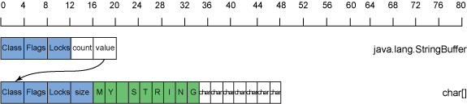

As [Figure 12](https://www.ibm.com/developerworks/library/j-codetoheap/#fig12) shows, 7 additional character entries available in the array are not being used but are consuming memory — in this case an additional overhead of 112 bytes. For this collection you have 9 entries in a capacity of 16, which gives you a fill ratio of 0.56. The lower a collection's fill ratio, the greater the overhead that is due to spare capacity.

## **Expansion and resizing of collections**

After a collection reaches its capacity and a request is made to put additional entries into the collection, the collection is resized and expanded to accommodate new entries. This increases the capacity but often lowers the fill ratio and introduces greater memory overhead.

The expansion algorithm used differs amongst the collections, but a common approach is to double the capacity of the collection. This is the approach taken for StringBuffer. In the case of the preceding example's StringBuffer, if you wanted to append " OF TEXT" to the buffer to produce "MY STRING OF TEXT", you need to expand the collection, because your new collection of characters has 17 entries against a current capacity of 16. Figure 13 shows the resulting memory usage:

##### **Figure 13. Memory usage of a StringBuffer containing "MY STRING OF TEXT" on a 32-bit Java runtime**

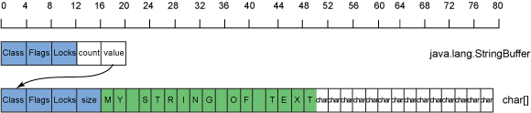

Now, as [Figure 13](https://www.ibm.com/developerworks/library/j-codetoheap/#fig13) shows, you have a 32-entry character array and 17 used entries, giving you a fill ratio of 0.53. The fill ratio hasn't dropped dramatically, but you now have an overhead of 240 bytes for the spare capacity.

In the case of small strings and collections, the overheads for low fill ratios and spare capacity might not seem to be too much of a problem, but they become much more apparent and expensive at greater sizes. For example, if you create a StringBuffer that contains just 16MB of data, it will be (by default) using a character array that is sized to hold up to 32MB of data — creating 16MB of additional overhead in the form of spare capacity.

## **Java Collections: Summary**

Table 8 summarizes the attributes of the collections:

##### **Table 8. Summary of collections attributes**

| **Collection** | **Performance** | **Default capacity** | **Empty size** | **10K entry overhead** |
| --- | --- | --- | --- | --- |
| HashSet | O(1) | 16 | 144 | 360K |
| HashMap | O(1) | 16 | 128 | 360K |
| Hashtable | O(1) | 11 | 104 | 360K |
| LinkedList | O(n) | 1 | 48 | 240K |
| ArrayList | O(n) | 10 | 88 | 40K |
| StringBuffer | O(1) | 16 | 72 | 24 |

The performance of the Hash collections is much better than that of either of the Lists, but at a much greater per-entry cost. Because of the access performance, if you are creating large collections (for example, to implement a cache), it's better to use a Hash-based collection, regardless of the additional overhead.

For smaller collections for which the access performance is less of an issue, Lists become an option. The performance of the ArrayList and the LinkedListcollections is approximately the same, but their memory footprints differ: the per-entry size of the ArrayList is much smaller than the LinkedList, but it is not accurately sized. Whether an ArrayList or a LinkedList is the right implementation of List to use depends on how predictable the length of the List is likely to be. If the length is unknown, a LinkedList may be the right option, because the collection will contain less empty space. If the size is known, an ArrayList will have much less memory overhead.

Choosing the correct collection type enables you to select the right balance between collection performance and memory footprint. In addition, you can minimize the memory footprint by correctly sizing the collection to maximize fill ratio and to minimize unused space.

## **Collections in use: PlantsByWebSphere and WebSphere Application Server Version 7**

In [Table 8](https://www.ibm.com/developerworks/library/j-codetoheap/#table8), the overhead of creating a 10,000-entry Hash-based collection is shown to be 360K. Given that it's not uncommon for complex Java applications to run with Java heaps sized in gigabytes, this does not seem like a large overhead — unless, of course, a large number of collections are being used.

Table 9 shows the collection-object usage as part of the 206MB of Java heap usage when the PlantsByWebSphere sample application supplied with WebSphere® Application Server Version 7 runs under a five-user load test:

##### **Table 9. Collection usage by PlantsByWebSphere on WebSphere Application Server v7**

| **Collection type** | **Number of instances** | **Total collection overhead (MB)** |
| --- | --- | --- |
| Hashtable | 262,234 | 26.5 |
| WeakHashMap | 19,562 | 12.6 |
| HashMap | 10,600 | 2.3 |
| ArrayList | 9,530 | 0.3 |
| HashSet | 1,551 | 1.0 |
| Vector | 1,271 | 0.04 |
| LinkedList | 1,148 | 0.1 |
| TreeMap | 299 | 0.03 |
| **Total** | **306,195** | **42.9** |

You can see from [Table 9](https://www.ibm.com/developerworks/library/j-codetoheap/#table9) that more than 300,000 different collections are being used — and that the collections themselves, not counting the data they contain, account for 42.9MB (21 percent) of the 206MB Java heap usage. This means that substantial potential memory savings are available if you either change collection types or ensure that the sizes of the collections are more accurate.

## **Looking for low fill ratios with Memory Analyzer**

The IBM Monitoring and Diagnostic Tools for Java - Memory Analyzer tool (Memory Analyzer) that is available as part of the IBM Support Assistant can analyze Java collections' memory usage (see [Related topics](https://www.ibm.com/developerworks/library/j-codetoheap/#artrelatedtopics)). Its capabilities include analysis of fill ratios and the sizes of collections. You can use this analysis to identify any collections that are candidates for optimization.

The collection-analysis capabilities in Memory Analyzer are located under the Open Query Browser -> Java Collections menu, as shown in Figure 14:

##### **Figure 14. Analysis of the fill ratio of Java collections in Memory Analyzer**

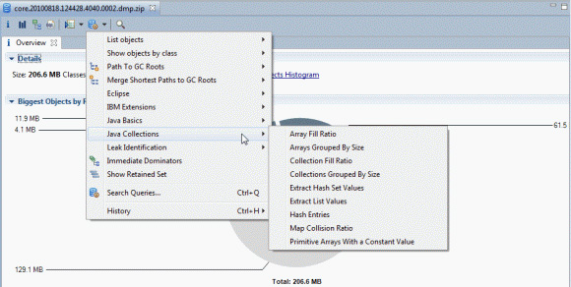

The Collection Fill Ratio query selected in [Figure 14](https://www.ibm.com/developerworks/library/j-codetoheap/#fig14) is the most useful for identifying collections that are much larger than currently required. You can specify a number of options for this query, including:

* **objects**: The types of objects (collections) you are interested in
* **segments**: The fill ratio ranges to group the objects into

Running the query with the objects options set to "java.util.Hashtable" and the segments option set to "10" produces the output shown in Figure 15:

##### **Figure 15. Analysis in Memory Analyzer of the fill ratio of Hashtables**

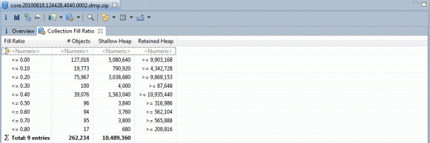

[Figure 15](https://www.ibm.com/developerworks/library/j-codetoheap/#fig15) shows that of the 262,234 instances of java.util.Hashtable, 127,016 (48.4 percent) of them are completely empty, and that almost all of them only have a small number of entries.

It's then possible to identify these collections by selecting a row of the results table and right-clicking to select either **list objects -> with incoming references**to see what objects own those collections or **list objects -> with outgoing references** to see what is inside those collections. Figure 16 shows the results of looking at the incoming references for the empty Hashtables and expanding a couple of the entries:

##### **Figure 16. Analysis of the incoming references to empty Hashtables in Memory Analyzer**

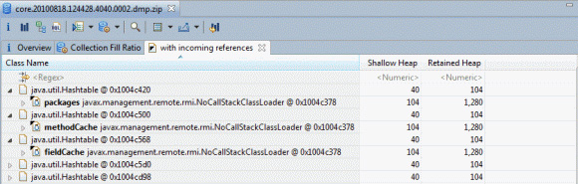

Figure 16 shows that some of the empty Hashtables are owned by thejavax.management.remote.rmi.NoCallStackClassLoader code.

By looking at the **Attributes** view in the left-hand panel of Memory Analyzer, you can see specific details about the Hashtable itself, as shown in Figure 17:

##### **Figure 17. Inspection of the empty Hashtable in Memory Analyzer**

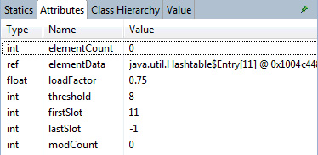

[Figure 17](https://www.ibm.com/developerworks/library/j-codetoheap/#fig3) shows that the Hashtable has a size of 11 (the default size) and that it is completely empty.

For the javax.management.remote.rmi.NoCallStackClassLoader code, it might be possible to optimize the collection usage by:

* Lazily allocating the Hashtable: If it is common for the Hashtable to be empty, then it may make sense for the Hashtable to be allocated only when there is data to store inside it.
* Allocating the Hashtable to an accurate size: Because the default size has been used, it's possible that a more accurate initial size could be used.

Whether either or both of these optimizations are applicable depends on how the code is commonly used, and what data is commonly stored inside it.

### **Empty collections in the PlantsByWebSphere example**

Table 10 shows the result of analyzing collections in the PlantsByWebSphere example to identifying those that are empty:

##### **Table 10. Empty-collection usage by PlantsByWebSphere on WebSphere Application Server v7**

| **Collection type** | **Number of instances** | **Empty instances** | **% Empty** |
| --- | --- | --- | --- |
| Hashtable | 262,234 | 127,016 | 48.4 |
| WeakHashMap | 19,562 | 19,465 | 99.5 |
| HashMap | 10,600 | 7,599 | 71.7 |
| ArrayList | 9,530 | 4,588 | 48.1 |
| HashSet | 1,551 | 866 | 55.8 |
| Vector | 1,271 | 622 | 48.9 |
| **Total** | **304,748** | **160,156** | **52.6** |

[Table 10](https://www.ibm.com/developerworks/library/j-codetoheap/#table10) shows that on average, over 50 percent of the collections are empty, implying that significant memory-footprint savings could be gained by optimization of collection usage. It could be applied to various levels of the application: in the PlantsByWebSphere example code, in the WebSphere Application Server, and in the Java collections classes themselves.

Between WebSphere Application Server version 7 and version 8, some work has been done to improve memory efficiency in the Java collections and middleware layers. For example, a large percentage of the overhead of instances of java.util.WeahHashMap is due to the fact that it contains an instance ofjava.lang.ref.ReferenceQueue to handle the weak references. Figure 18 shows the memory layout of a WeakHashMap for a 32-bit Java runtime:

##### **Figure 18. Memory layout of a WeakHashMap for a 32-bit Java runtime**

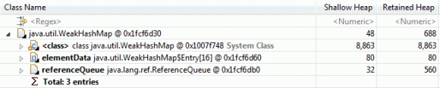

[Figure 18](https://www.ibm.com/developerworks/library/j-codetoheap/#fig18) shows that the ReferenceQueue object is responsible for retaining 560 bytes' worth of data, even if the WeakHashMap is empty and ReferenceQueue is therefore not required. For the PlantsByWebSphere example case with 19,465 empty WeakHashMaps, the ReferenceQueue objects are adding an additional 10.9MB of data that is not required. In WebSphere Application Server version 8 and the Java 7 release of the IBM Java runtimes, the WeakHashMap has undergone some optimization: It contains a ReferenceQueue, which in turn contains an array of Reference objects. That array has been changed to be allocated lazily — that is, only when objects are added to the ReferenceQueue.

## **Conclusion**

A large and perhaps surprising number of collections exist in any given application, and more so for complex applications. Use of a large number of collections often provides scope for achieving sometimes significant memory-footprint savings by selecting the right collection, sizing it correctly, and potentially by allocating it lazily. These decisions are best made during design and development, but you can also use the Memory Analyzer tool to analyze your existing applications for potential memory-footprint optimization.